Template index

This journal operates a **double-blind review process**, which means the identities of the authors are concealed from the reviewers, and vice versa. To facilitate this, please include the following **in separately files**:

***Title Page (With Author Information)***: This should include the title, authors' names, affiliations, acknowledgements and any Declaration of Interest statement, and a complete address for the corresponding author including an e-mail address.

***Anonymized Manuscript (Without Author Information)***: The main body of the paper (including the references, figures, tables and any acknowledgements) should not include any identifying information, such as the authors' names or affiliations.

***Declaration of Interest Statement***: All authors must disclose any financial and personal relationships with other people or organizations that could inappropriately influence (bias) their work. Examples of potential conflicts of interest include employment, consultancies, stock ownership, honoraria, paid expert testimony, patent applications/registrations, and grants or other funding. Authors should complete the declaration of competing interest statement and upload to the submission system at the Attach Files step. **Note: Please do not convert the .docx template to another file type. Author signatures are not required.**

**Table of content**

Template index 1

Title Page (With Author Information) 2

Manuscript (Without Author Information) 4

Declaration of Interest Statement 8

Title Page (With Author Information)

**Title**

(Title usually falls within 2−3 lines. All lexical words, as well as prepositions over 5 letters (including 5) should be initials in capital.)

First name Last namea, First name Last nameb, First name Last nameb,*

a School of Architecture, Tsinghua University, Beijing, China;

b Department of Architecture and Design, Politecnico di Torino, Torino, Italy

(Author affiliations should be listed according to the name order under the paper title. The corresponding author should be marked with “*” on the top right.)

* Corresponding author.

E-mail address: [e-mail@e-mail.com](mailto:e-mail@e-mail.com) (author initials).

**Abstract**

(Abstract should be about 150−200 words which can conclude the whole content of the paper, including purpose, method, results and conclusion. Equations, figures and tables, as well as references are not supposed to appear in this part. When abbreviation is firstly used, it should contain the full name with its abbreviation included in parentheses, such as “mixed multinominal logit (MMNL) model”. Do NOT use the first person as subject. Do NOT repeat the title as the first sentence of the abstract. Simple sentences and active voice are preferred, and verb should be close to the subject.)

*Design Science Vision (DSV)* is an interdisciplinary research journal that publishes high-quality papers focused on the built environment and its design interventions. The journal welcomes cross-disciplinary research bridges the gap between built environment design and fields such as data science, decision science, computational science and cognitive science. Priority is given to studies offering innovative solutions and fundamental insights into urbanization and the future of human living spaces.

*DSV* provides both readers and authors with high visibility, emphasising interdisciplinary communication and ensuring accessibility to a broad readership. The journal maintains high standards in copy editing and production, rigorous peer review and rapid publication, as well as operates independently of academic societies and other vested interests.

**Keywords:** decision science; computational science; cognitive science; data science

(About 5-8 words separated with “;”; use small letters except technical terms. Abbreviations should contain full name with abbreviation included in parentheses.)

**Acknowledgments**

The authors would like to acknowledge the National Natural Science Foundation of China (Grant No.: xxxxxx), Open Foundation of Hypervelocity Impact Research Center of CARDC (Grant No.: 20180201) and Open Project of State Key Laboratory of Explosion Science and technology in Beijing Institute of Technology (Grant No.: xxxxxx) to provide fund for conducting experiments.

(If no funding has been provided for the research, it is recommended to include the following sentence: *This research did not receive any specific grant from funding agencies in the public, commercial, or not-for-profit sectors.*)

**Ethics Statements**

*Ethics approval and consent to participate*

Manuscripts reporting studies involving human participants, human data or human tissue must:

• include a statement on ethics approval and consent (even where the need for approval was waived)

• include the name of the ethics committee that approved the study and the committee's reference number if appropriate

*Consent for publication:*

If your research or manuscript contains any individual person's data in any form (including any individual details, images or videos), consent for publication must be obtained from that person, or in the case of children, their parent or legal guardian. All presentations of case reports must have consent for publication.

Manuscript (Without Author Information)

Article type (Research article, Review, Short communication, etc.)

**Title**

(Title usually falls within 2−3 lines. All lexical words, as well as prepositions over 5 letters (including 5) should be initials in capital.)

**Abstract**

(Abstract should be about 150−200 words which can conclude the whole content of the paper, including purpose, method, results and conclusion. Equations, figures and tables, as well as references are not supposed to appear in this part. When abbreviation is firstly used, it should contain the full name with its abbreviation included in parentheses, such as “mixed multinominal logit (MMNL) model”. Do NOT use the first person as subject. Do NOT repeat the title as the first sentence of the abstract. Simple sentences and active voice are preferred, and verb should be close to the subject.)

*Design Science Vision (DSV)* is an interdisciplinary research journal that publishes high-quality papers focused on the built environment and its design interventions. The journal welcomes cross-disciplinary research bridges the gap between built environment design and fields such as data science, decision science, computational science and cognitive science. Priority is given to studies offering innovative solutions and fundamental insights into urbanization and the future of human living spaces.

*DSV* provides both readers and authors with high visibility, emphasising interdisciplinary communication and ensuring accessibility to a broad readership. The journal maintains high standards in copy editing and production, rigorous peer review and rapid publication, as well as operates independently of academic societies and other vested interests.

**Keywords:** decision science; computational science; cognitive science; data science

(About 5-8 words separated with “;”; use small letters except technical terms. Abbreviations should contain full name with abbreviation included in parentheses.)

**1. Introduction**

Design, one of the most important creative activities in the history of human civilization, is the process of creating products, solutions, or systems with specific functions, through the planning and organization of resources to meet defined goals and requirements (Lastname, 2024). It is deeply embedded in the shaping of the built environment where humans reside.

Design determines whether people can enjoy safe, healthy, and livable spaces, and whether an ideal balance can be achieved between resource input and demand fulfillment.

(Equations, figures and tables are usually not supposed to appear in this part.)

**2. Material and methods**

*2.1．*

*2.2．*

*2.2.1．*

*2.2.2．*

**3. Results**

*3.1．*

*3.2．*

*3.2.1．*

(A detailed guide on electronic artwork is available on our website: <https://www.elsevier.com/about/policies-and-standards/author/artwork-and-media-instructions>. You are urged to visit this site; some excerpts from the detailed information are given here. **Ensure all figure and table citations in the text match the files provided.**)

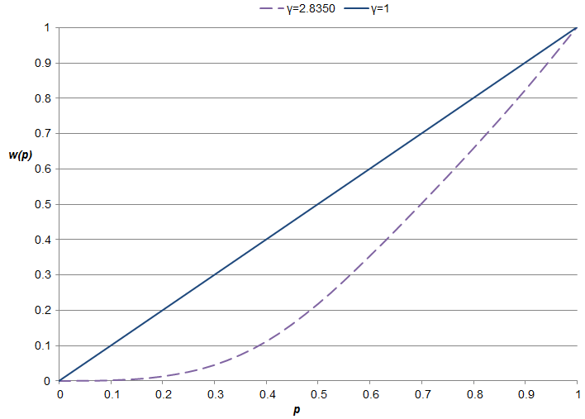

Fig. 1.All figures (include relevant captions)

Table 1. All tables (including titles, description, footnotes)

|  |  |  |  |  |
| --- | --- | --- | --- | --- |
| Variable | | Coefficient | | *t-Ratio* |
| *Nonrandom parameters:* | | | | |
| Reference constant | 0.6406 | | 4.51 | |
| Cost ($) | −0.3887 | | −9.62 | |
| Tollasc | −0.4259 | | −2.65 | |
| Age (years, reference (first) alternative only) | 0.0174 | | 6.25 | |
| *Means for random parameters:* | | | | |
| Alpha (α) | 0.7174 | | 94.94 | |
| Probability weighted travel time (minutes) | −1.3095 | | −47.22 | |
| *Standard deviations for random parameters:* | | | | |
| Alpha (α) | 0.3444 | | 25.94 | |
| Probability Weighted Travel Time (minutes) | 1.3095 | | 47.22 | |
| No. of observations | 4,480 | | | |
| McFadden Pseudo R-squared | 0.419 | | | |
| Log-likelihood | −2,858.15 | | | |

**4. Discussion**

*4.1.*

*4.2.*

**5. Conclusions**

(Conclusion should be summarized in points without tedious description of background, method, etc.)

**References**

**Reference format**

This journal does not set strict requirements on reference formatting at submission. Nevertheless, we recommend formatting the references in the **APA style** used by the journal. Details concerning this referencing style can also be found at <https://apastyle.apa.org/instructional-aids/reference-guide.pdf>

*Some suggestion:*

- References can be in any style or format if the style is consistent.

- Author names, journal or book titles, chapter or article titles, year of publication, volume numbers, article numbers or pagination must be included, where applicable.

- Use of DOIs is recommended.

Our journal reference style will be applied to your article after acceptance, at proof stage. If required, at this stage we will ask you to correct or supply any missing reference data.

**Reference citing in the manuscript:** author-date format. (Please ensure that every reference cited in the text is also present in the reference list and vice versa.)

**Single author:** the author’s name (without initials, unless there is ambiguity) and the year of publication;

**Two authors:** both authors’ names and the year of publication.

**Three or more authors:** first author’s name followed by ‘et al.’ and the year of publication.

Citations may be made directly (or parenthetically). Groups of references should be listed first alphabetically, then chronologically.

**Examples:**

as demonstrated (Allan, 1996a, 1996b, 1999; Allan and Jones, 1995)

Kramer et al. (2000) have recently shown ....

**List of References** in the end of the manuscript should be arranged first alphabetically and then further sorted chronologically if necessary. More than one reference from the same author(s) in the same year must be identified by the letters “a”, “b”, “c”, etc., placed after the year of publication.

**Appendix A. Supplementary data**

Supplementary data to this article.

Declaration of Interest Statement

The authors declare that they have no known competing financial interests or personal relationships that could have appeared to influence the work reported in this paper.

The author *Click here to enter your name* is Choose an item for *Click here to enter the journal’s name* and was not involved in the editorial review or the decision to publish this article.

The authors declare the following financial interests (e.g., any funding for the research project)/personal relationships (e.g., the author is an employee of a profitable company) which may be considered as potential competing interests:

Click here to enter your full declaration