**Please pay extra attention to the highlighted text, please don’t replace the bold text.**

**Type of the Paper** (Original article, Short Rapid Communication.)

**Title:** Concise and informative, Titles are often used in information-retrieval systems. Avoid abbreviations and formulae where possible. A maximum of 30 words.

Firstname Middlename initial. Lastnamea, Firstname Middlename initial. Lastnameb and Firstname Middlename initial. Lastnameb,*

a Institute for Health and Sport, Victoria University, Melbourne, Australia

b Hubei Key Laboratory of Exercise Training and Monitoring, Wuhan Sports University, Wuhan, China

**\* Corresponding to:** mail address

**E-mail address:** [email@email.com](mailto:email@email.com) (Firstname initial. Lastname).

**Abstract:** A concise and factual abstract is required. The abstract should state briefly the purpose of the research, participants/subjects/experimental model (as applicable), the principal results and major conclusions. An abstract is often presented separately from the article, so it must be able to stand alone. For this reason, references should be avoided. Also, non-standard or uncommon abbreviations should be avoided, but if essential they must be defined at their first mention in the abstract itself. A maximum of 350 words.

**Keywords:** keyword 1; keyword 2; keyword 3. Provide a maximum of 6 keywords, avoiding general and plural terms and multiple concepts (avoid, for example, 'and', 'of'). Be sparing with abbreviations: only abbreviations firmly established in the field may be eligible. These keywords will be used for indexing purposes.

1. **Introduction**

State the objectives of the work and provide an adequate background, avoiding a detailed literature survey or a summary of the results.

1. **Materials and methods**

Provide sufficient details to allow the work to be reproduced by an independent researcher. Methods that are already published should be summarized, and indicated by a reference. If quoting directly from a previously published method, use quotation marks and also cite the source. Any modifications to existing methods should also be described. For studies involving animals or humans, as well as other studies that necessitate ethical approval, it is essential to include the approving authority and the corresponding ethical approval code.

1. **Results**

Results should be clear and concise. For quantitative data provide p-values when possible.

3.1. Subsection

3.1.1. Subsubsection

3.2. Figures, Tables and Schemes

Please ensure the high-resolution (a minimum of 1000 pixels in width/height, or a resolution of 300 dpi or higher) figures and the tables included in the single file are placed next to the relevant text in the manuscript, rather than at the bottom or the top of the file. The corresponding caption should be placed directly below the figure or table.

Whilst it is accepted that authors sometimes need to manipulate images for clarity, manipulation for purposes of deception or fraud will be seen as scientific ethical abuse and will be dealt with accordingly. For graphical images, this journal is applying the following policy: no specific feature within an image may be enhanced, obscured, moved, removed, or introduced. Adjustments of brightness, contrast, or color balance are acceptable if and as long as they do not obscure or eliminate any information present in the original. Nonlinear adjustments (e.g. changes to gamma settings) must be disclosed in the figure legend.

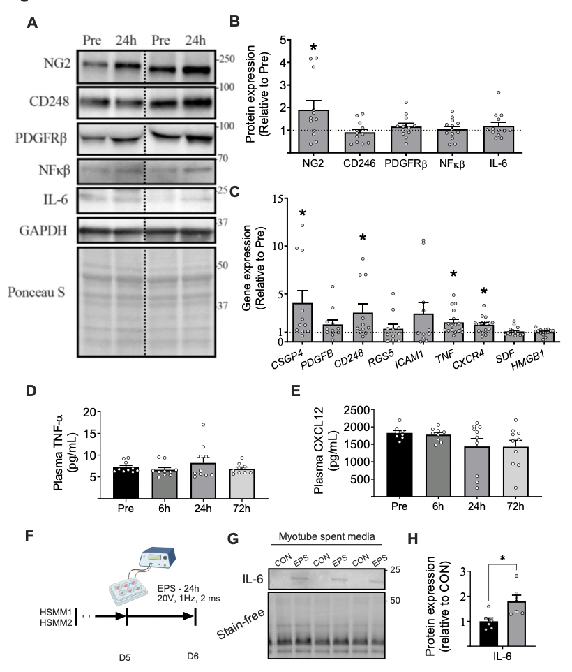

**Fig. 1.** This is a figure title. Describe all abbreviations and symbols used in the figure. The figure and figure legend should be able to stand alone and be interpreted. Figures should be placed in the main text near to the first time they are cited.

Table 1. This is a table title. Describe all abbreviations and symbols used in the table. The table and table legend should be able to stand alone and be interpreted. Tables should be placed in the main text near to the first time they are cited.

|  |  |  |
| --- | --- | --- |
| **Title 1** | **Title 2** | **Title 3** |
| data | data | data |
| data | data | data |

For more details, please see Guide for Authors.

1. **Discussion**

This should explore the significance of the results of the work as they relate to the scientific literature, not just repeat the results. The implications of the work for practice is encouraged at the end of the discussion.

1. **Conclusions**

The main conclusions of the study are to be presented in a clear and concise manner, which may stand alone or form a subsection of a Discussion section.

**Ethical approval**

Manuscripts reporting studies involving human participants, human data or human tissue must:

include a statement on ethics approval and consent (even where the need for approval was waived)

include the name of the ethics committee that approved the study and the committee's reference number if appropriate

All materials must adhere to high ethical and animal welfare standards. Any use of animals must be based on ethological knowledge and respect for species-specific requirements for health and well-being. A statement indicating that the protocol and procedures employed were ethically reviewed and approved, and the name of the body giving approval, must be included in the Methods section of the manuscript.

**CRediT authorship contribution statement**

Firstname Middlename initial. Lastname**:** Writing – review & editing, Writing – original draft, Visualization, Project administration, Data curation. Firstname Middlename initial. Lastname**:** Writing – review & editing, Writing – original draft, Data curation. Firstname Middlename initial. Lastname**:** Writing – original draft. Firstname Middlename initial. Lastname**:** Writing – original draft. Firstname Middlename initial. Lastname**:** Writing – review & editing, Writing – original draft, Conceptualization, Supervision.

**Funding**

This work was supported by the National Institutes of Health [grant numbers xxxx, yyyy]; the Bill & Melinda Gates Foundation, Seattle, WA [grant number zzzz]; and the United States Institutes of Peace [grant number aaaa].

This section must be included in all manuscripts at the end of the article before the references. List funding sources in this standard way to facilitate compliance to funder's requirements:  
It is not necessary to include detailed descriptions on the program or type of grants and awards. When funding is from a block grant or other resources available to a university, college, or other research institution, submit the name of the institute or organization that provided the funding.  
If no funding has been provided for the research, please include the following sentence:  
This research did not receive any specific grant from funding agencies in the public, commercial, or not-for-profit sectors.

**Declaration of Competing interests**

The authors declare that they have no known competing financial interests or personal relationships that could have appeared to influence the work reported in this paper.

The author is an Editorial Board Member/Editor-in-Chief/Associate Editor/Guest Editor for [Journal name] and was not involved in the editorial review or the decision to publish this article.

The authors declare the following financial interests/personal relationships which may be considered as potential competing interests:

**Acknowledgements**

Acknowledge here those individuals who provided help during the research (e.g., providing language help, writing assistance or proof reading the article, etc.), but did not meet the criteria for authorship. If there are no acknowledgments then this section is not required.

**Supplementary Material**

**S**upplementary material such as applications, images and sound clips, can be published with your article to enhance it. Submitted supplementary items are published exactly as they are received (Excel or PowerPoint files will appear as such online). Please submit your material together with the article and supply a concise, descriptive caption for each supplementary file.

References

Indicate references in the text by using superscript Arabic numerals in the order in which they appear in the text. The numerals are to be used outside periods and commas, inside colons and semicolons. For further detail and examples, you are referred to the [Manual of Style, A Guide for Authors and Editors, 11th Edition](https://www.amamanualofstyle.com/AMA). Then remove the DIO hyperlink from the template.

In the reference list, number the references in the order in which they appear in the text.

Examples:

**Reference to a journal publication:**

Van der Geer J, Handgraaf T, Lupton RA. The art of writing a scientific article. J Sci Commun. 2020;163:51–59.

**Reference to a journal publication with an article number:**

Van der Geer J, Handgraaf T, Lupton RA. The art of writing a scientific article. Heliyon. 2022;19:e00205.

**Reference to a book:**

Strunk W Jr, White EB. The Elements of Style. 4th ed. New York, NY: Longman; 2000.

**Reference to a chapter in a book:**

Mettam GR, Adams LB. How to prepare an electronic version of your article. In: Jones BS, Smith RZ, eds. Introduction to the Electronic Age. New York, NY: E-Publishing Inc; 2020:281–304.

**Reference to a website:**

Cancer Research UK. Cancer statistics reports for the UK. Accessed 13 March 2023.

<http://www.cancerresearchuk.org/aboutcancer/statistics/cancerstatsreport/;> 2023.

**Reference to a dataset:**

Oguro M, Imahiro S, Saito S, Nakashizuka T. Mortality data for Japanese oak wilt disease and surrounding forest compositions [dataset], Mendeley Data, v1; 2015.

**Reference to software:**

Coon E, Berndt M, Jan A, Svyatsky D, Atchley A, Kikinzon E, Harp D, Manzini G, Shelef E, Lipnikov K, Garimella R, Xu C, Moulton D, Karra S, Painter S, Jafarov E, Molins S. Advanced Terrestrial Simulator (ATS) v0.88 (Version 0.88) [computer software]. ]Zenodo; 2020, March 25.